**CRM Guide: Payables to Contractors**

Finance → Payables → Payable to Contractor

*A step-by-step visual guide to processing contractor invoice payments*

# **Overview**

The Payable to Contractor section allows you to pay contractors for maintenance and repair work carried out at managed properties. Each row in the list represents a single contractor invoice linked to a property (and optionally a Maintenance Work Order).

There are three ways to process contractor payments:

* Method 1 – Pay Individually: Click the Pay button next to a single invoice to record a one-off payment.
* Method 2 – Batch EFT/BACs: Tick the EFT checkbox on multiple invoices and process them all at once as a BACs file.
* Method 3 – Bulk Mark as Paid: Select multiple invoices using the Client Account checkboxes and use the Mark as paid button to record payments in bulk.

You can also apply a commission deduction to any invoice before paying, to retain your agency fee from the contractor payment.

# **Navigating to Payable to Contractor**

**Step 1: Open the Payable to Contractor Tab**

From the left-hand menu, click Finance → Payables. In the tab bar at the top of the page, click Payable to Contractor. The page heading will read 'Payable to Contractors' and shows the total number of payables and total outstanding amount in the top-right corner.

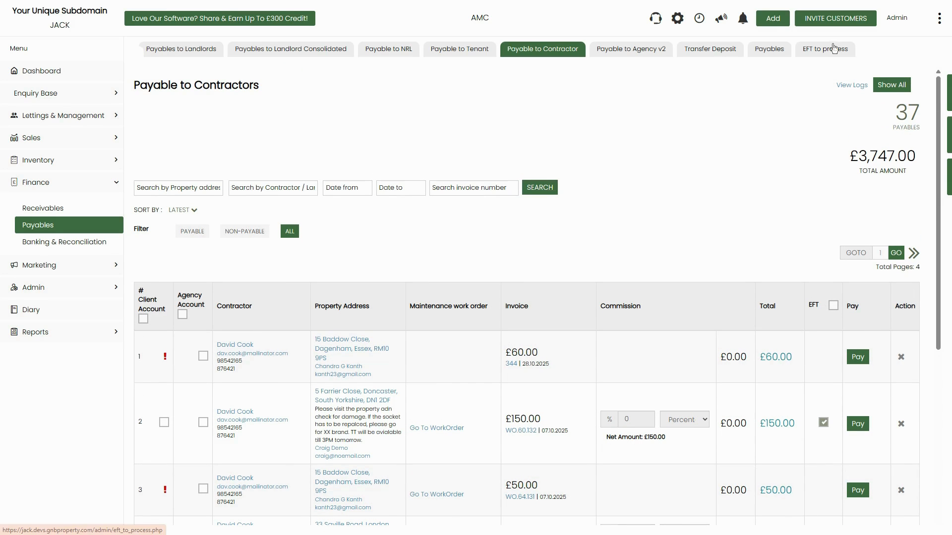

*Figure 1: Payable to Contractors page — 37 payables totalling £3,747.00. Each row shows contractor, property, invoice, commission, total, EFT checkbox, Pay button, and Action (delete) icons*

**Step 2: Understand the Page Columns**

Each row in the list represents one contractor invoice. The key columns are:

* # Client Account — Tick to select for bulk payment. A red exclamation mark (!) icon means the invoice has not yet been deducted from a landlord or tenant statement and cannot be paid yet.
* Agency Account — Tick to assign the payment to the agency account instead of the client account.
* Contractor — Contractor's name, email, and phone number.
* Property Address — The property the work was carried out at, with the landlord/tenant contact details shown below the address.
* Maintenance work order — A link to the related work order (if one exists). Click 'Go To WorkOrder' to open it.
* Invoice — Invoice amount and invoice number with date.
* Commission — Enter a percentage or flat amount to deduct your agency fee. The Net Amount shown below updates automatically.
* Total — The net amount payable to the contractor after commission deduction.
* EFT — Tick to add this invoice to the EFT/BACs batch queue.
* Pay — Green button to pay this invoice individually.
* Action (✕) — Deletes/removes the invoice from the payables list.

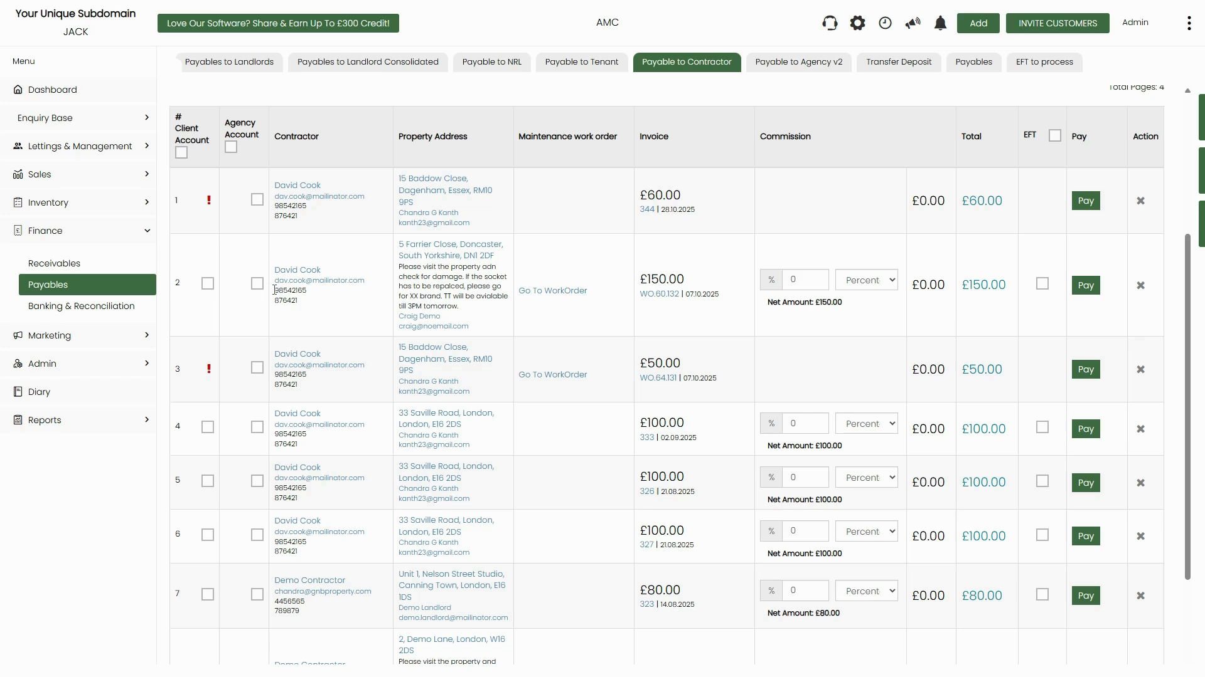

*Figure 2: Detailed view of payables list — shows commission field with Net Amount, and the red ! icon for invoices not yet deducted from statements*

**Step 3: Understand the Red ! (Exclamation) Icon**

The red exclamation mark icon in the # Client Account column means the invoice has not yet been deducted from the relevant landlord or tenant's statement. Hovering over the icon shows the tooltip: 'Payment remains not payable as it has not yet been deducted from Landlord / Tenant Statement.'

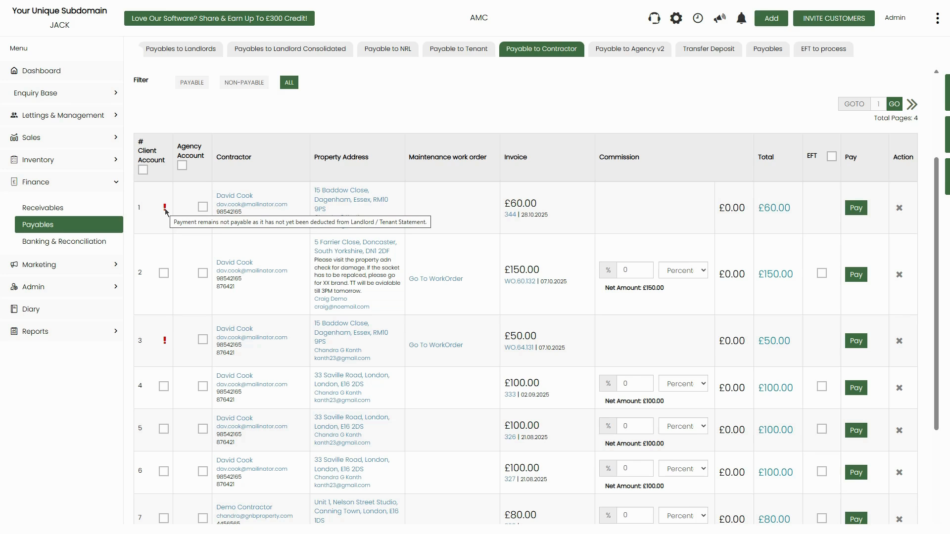

*Figure 3: Tooltip on the red ! icon — this invoice cannot be paid until it has first been deducted from the landlord/tenant statement*

**⚠️ Important:** You cannot pay invoices marked with the red ! icon. First ensure the charge has been deducted from the landlord or tenant statement. Once deducted, the icon will clear and the invoice will become payable.

**Step 4: Use the Search and Filter Options**

The page provides search fields to find specific invoices. You can search by property address, contractor or landlord name, date range (from/to), or invoice number. Click SEARCH to apply. Use the Sort By dropdown to order results by latest, oldest, or other criteria.

Use the Filter buttons below the search bar to narrow the list by status:

* PAYABLE — Shows only invoices ready to be paid (no red ! icon).
* NON-PAYABLE — Shows only invoices blocked by the red ! icon.
* ALL — Shows all invoices regardless of status (default view).

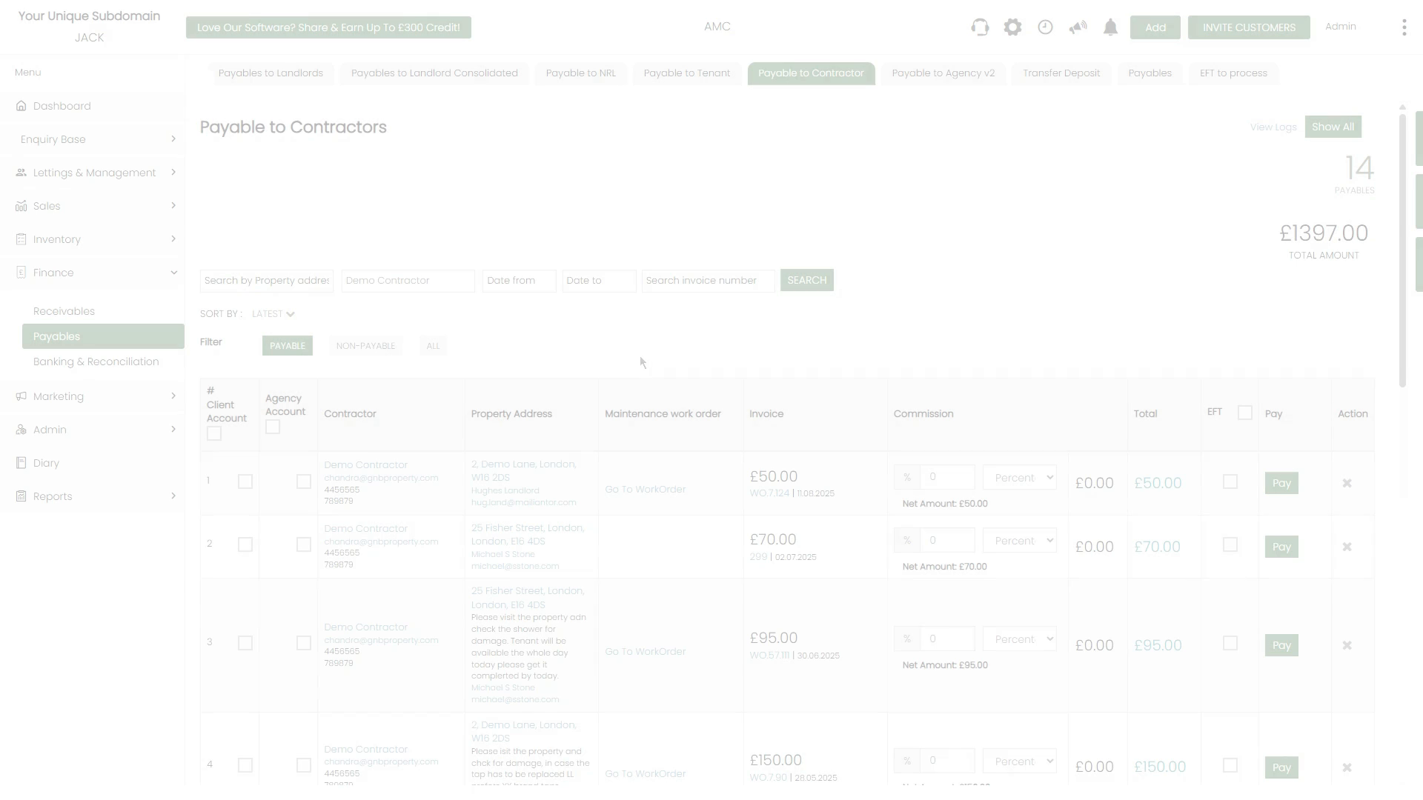

*Figure 4: Filtered view showing only PAYABLE invoices for 'Demo Contractor' — 14 payables totalling £1,397.00*

# **Setting Commission Before Paying**

**Step 1: Enter a Commission Deduction**

Before paying any invoice, you can deduct your agency commission directly from the contractor payment. In the Commission column, enter either:

* A percentage (%) — e.g. enter 10 in the % field and select 'Percentage' from the dropdown. The Net Amount will update to show the invoice total minus the commission (e.g. £150.00 at 10% = £15.00 commission, Net Amount £135.00).
* A flat amount — Select 'Amount' from the dropdown and enter the fixed commission value.

The Total column updates automatically to reflect the net amount that will be paid to the contractor after the commission is deducted.

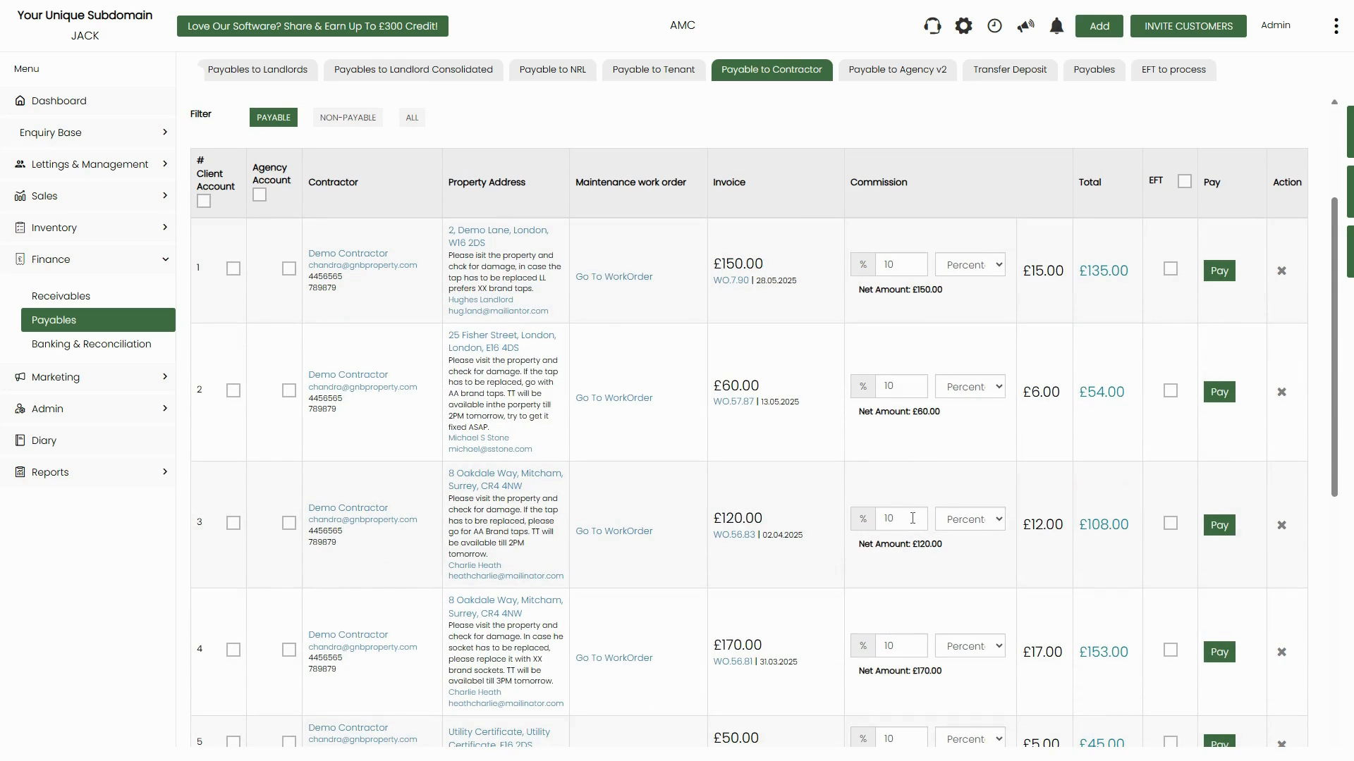

*Figure 5: Commission set to 10% on multiple invoices — commission amounts and net totals update automatically per row*

**📌 Note:** Commission deductions are recorded against each invoice individually. You can set different commission rates for different invoices on the same page. The Selected Commission Amount summary in the top area shows the total commission being retained across all selected rows.

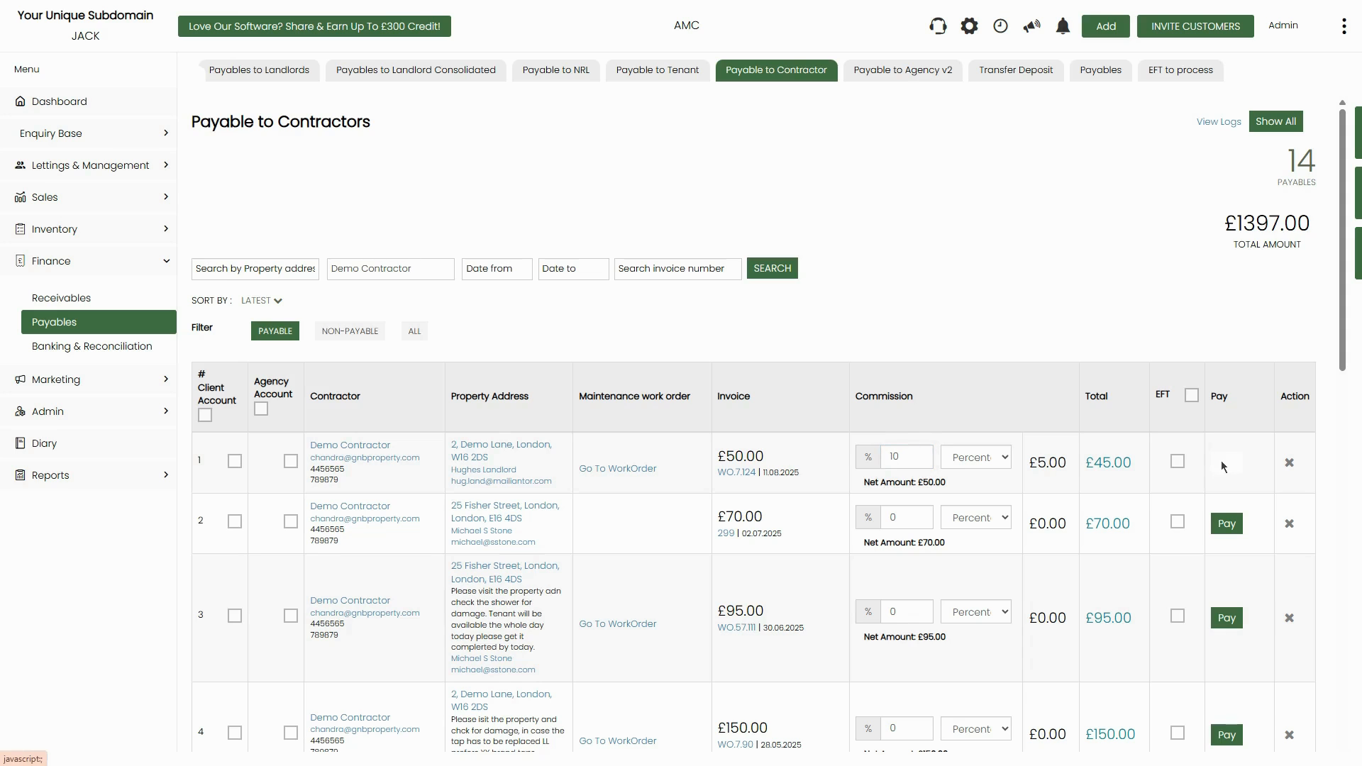

*Figure 6: After setting commission, the top summary shows Selected Commission Amount (£5.00) and Selected Amount (£210.00) for ticked rows*

# **Method 1: Pay an Invoice Individually**

**Step 1: Click the Pay Button**

Find the invoice you want to pay in the list. Click the green Pay button in the Pay column. This opens the Mark as paid dialog for that specific invoice.

**Step 2: Complete the Mark as Paid Form**

The dialog shows the contractor name, invoice number, and property address at the top. Fill in the following fields:

* Amount paid — Pre-filled with the invoice total (after any commission). Edit if paying a partial amount.
* Payment date — Enter the date the payment was/will be made.
* Payment method — Select from the dropdown (Bank Transfer, BACs Transfer, Cash, Cheque, etc.).
* Paying from — Select the client bank account the payment is drawn from.
* Bank / Your reference — Enter a payment reference number.
* Statement Remark — Enter a description that will appear on the contractor's payment record.

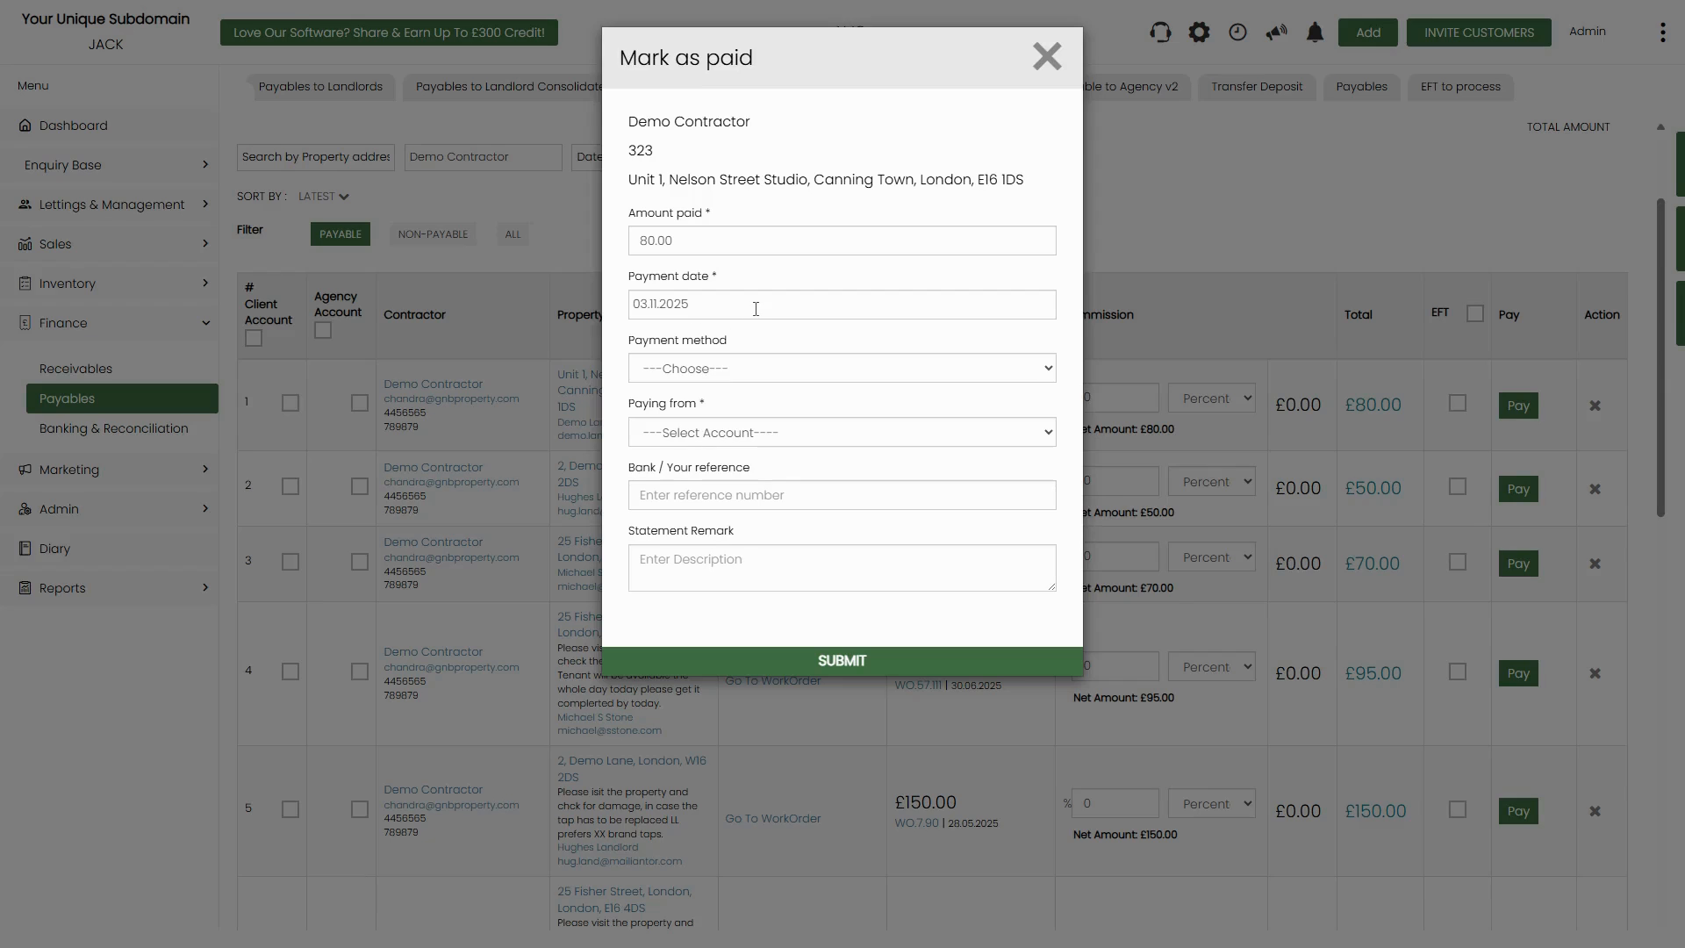

*Figure 7: Mark as paid dialog for a single invoice — fill in all required fields then click SUBMIT*

**Step 3: Submit the Payment**

Once all fields are completed, click the green SUBMIT button at the bottom of the dialog. The invoice will be marked as paid and removed from the PAYABLE list. It will appear in the contractor's payment history.

# **Method 2: Batch EFT/BACs Payment**

**Step 1: Tick the EFT Checkbox for Each Invoice**

On the Payable to Contractors list, tick the EFT checkbox in the EFT column for each invoice you want to include in the batch payment. You can also tick the EFT header checkbox at the top of the column to select all visible rows at once.



*Figure 8: EFT checkbox ticked for row 2 — this invoice will be added to the batch EFT queue*

**Step 2: Go to the EFT to Process Tab**

Click the EFT to process tab in the top navigation bar. This page shows all invoices that have been added to the EFT queue, grouped with their contractor bank details and amounts. The top-right summary shows Total Items and Total Amount for the batch.

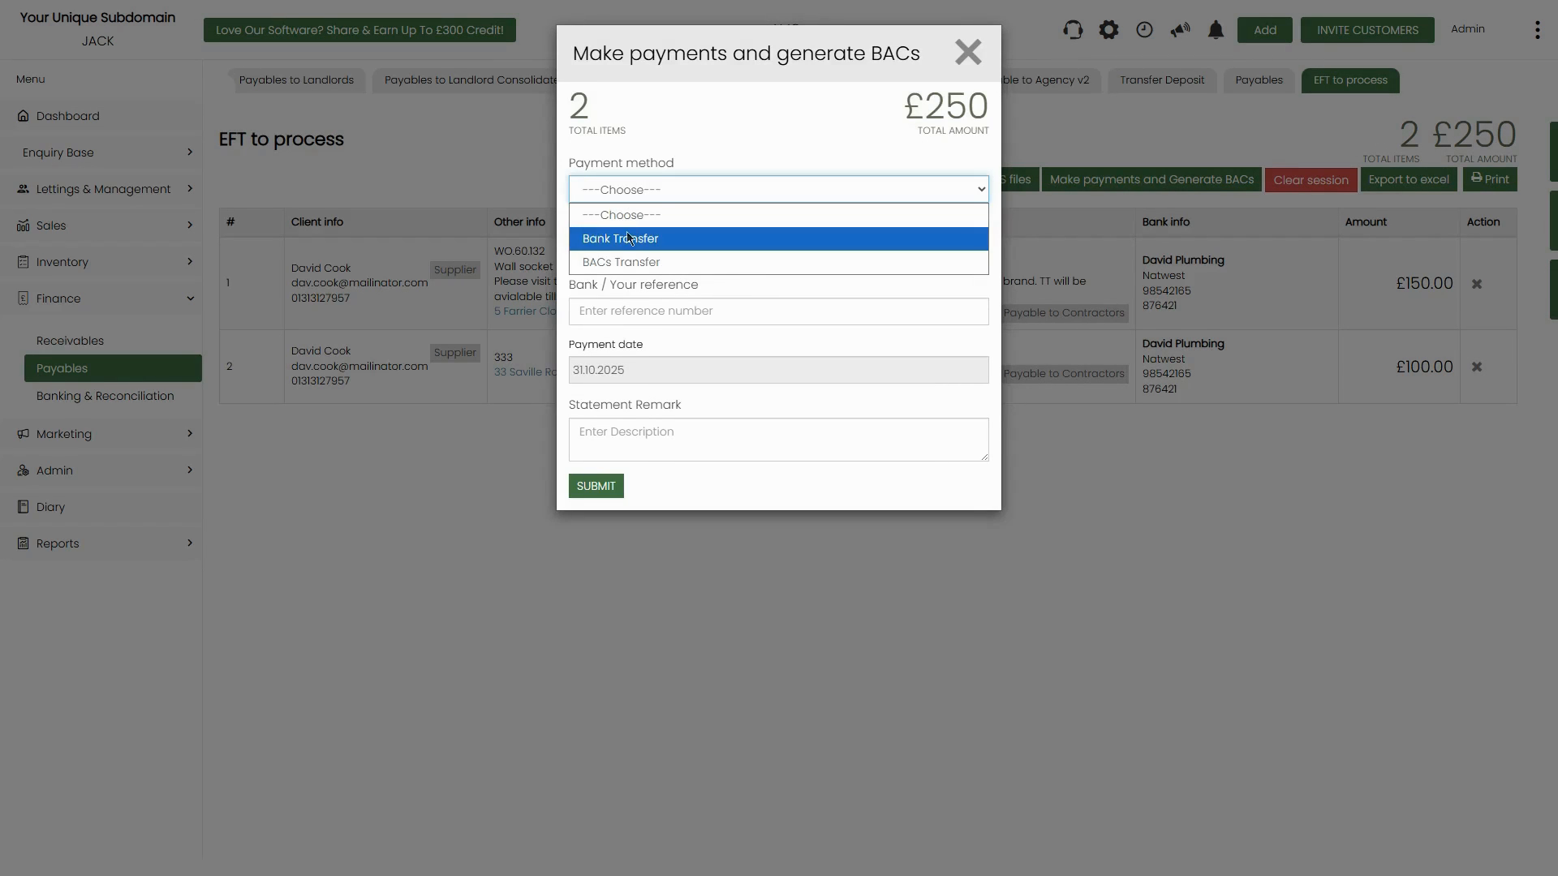

*Figure 9: EFT to process tab showing 2 contractor invoices totalling £250 — bank details shown for each*

**Step 3: Click 'Make Payments and Generate BACs'**

Click the Make payments and Generate BACs button. This opens the payment confirmation dialog showing the total items and total amount. Fill in:

* Payment method — Select Bank Transfer or BACs Transfer.
* Bank / Your reference — Enter a batch reference.
* Payment date — Pre-filled with today's date; edit if needed.
* Statement Remark — Enter a description for the batch.



*Figure 10: Make payments and Generate BACs dialog — payment method dropdown showing Bank Transfer and BACs Transfer options*

**Step 4: Submit and Save the BACs File**

Click SUBMIT. The system processes each payment one by one, showing a progress counter (e.g. 1 / 2, 'Please wait while we make payments'). Do not close or refresh the page during this process.

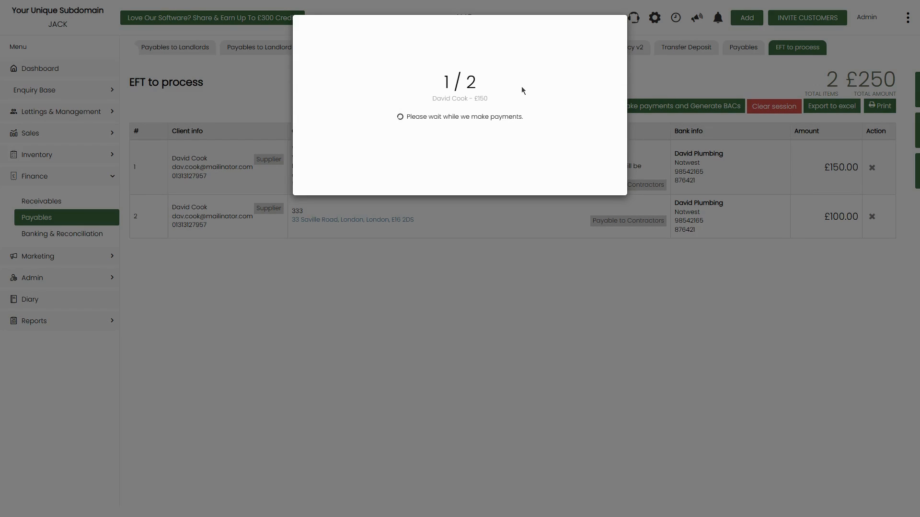

*Figure 11: Payment processing progress dialog — '1 / 2 David Cook – £150. Please wait while we make payments'*

Once complete, a Save As dialog appears for you to save the BACs file (a .txt file) to your computer. Save it to the appropriate location and then submit it to your bank.

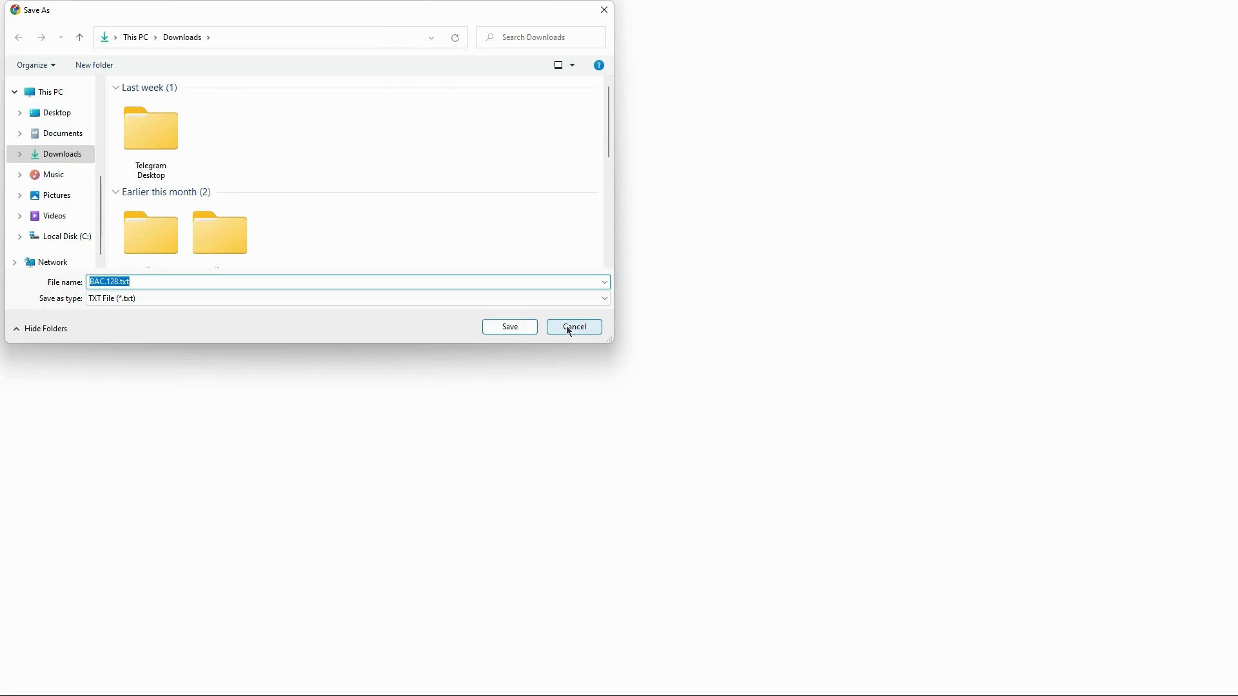

*Figure 12: Save As dialog — save the generated BACs .txt file to your computer for submission to the bank*

**📌 Note:** The Exported BACs files button on the EFT to process tab lets you re-download previously generated BACs files if needed.

# **Method 3: Bulk Mark as Paid**

**Step 1: Tick the Client Account Checkboxes**

On the Payable to Contractors list, tick the checkbox in the # Client Account column for each invoice you want to mark as paid. As you tick rows, the top-right summary updates to show Selected Commission Amount and Selected Amount totals. The Mark as paid button appears in the top-right area once at least one row is selected.

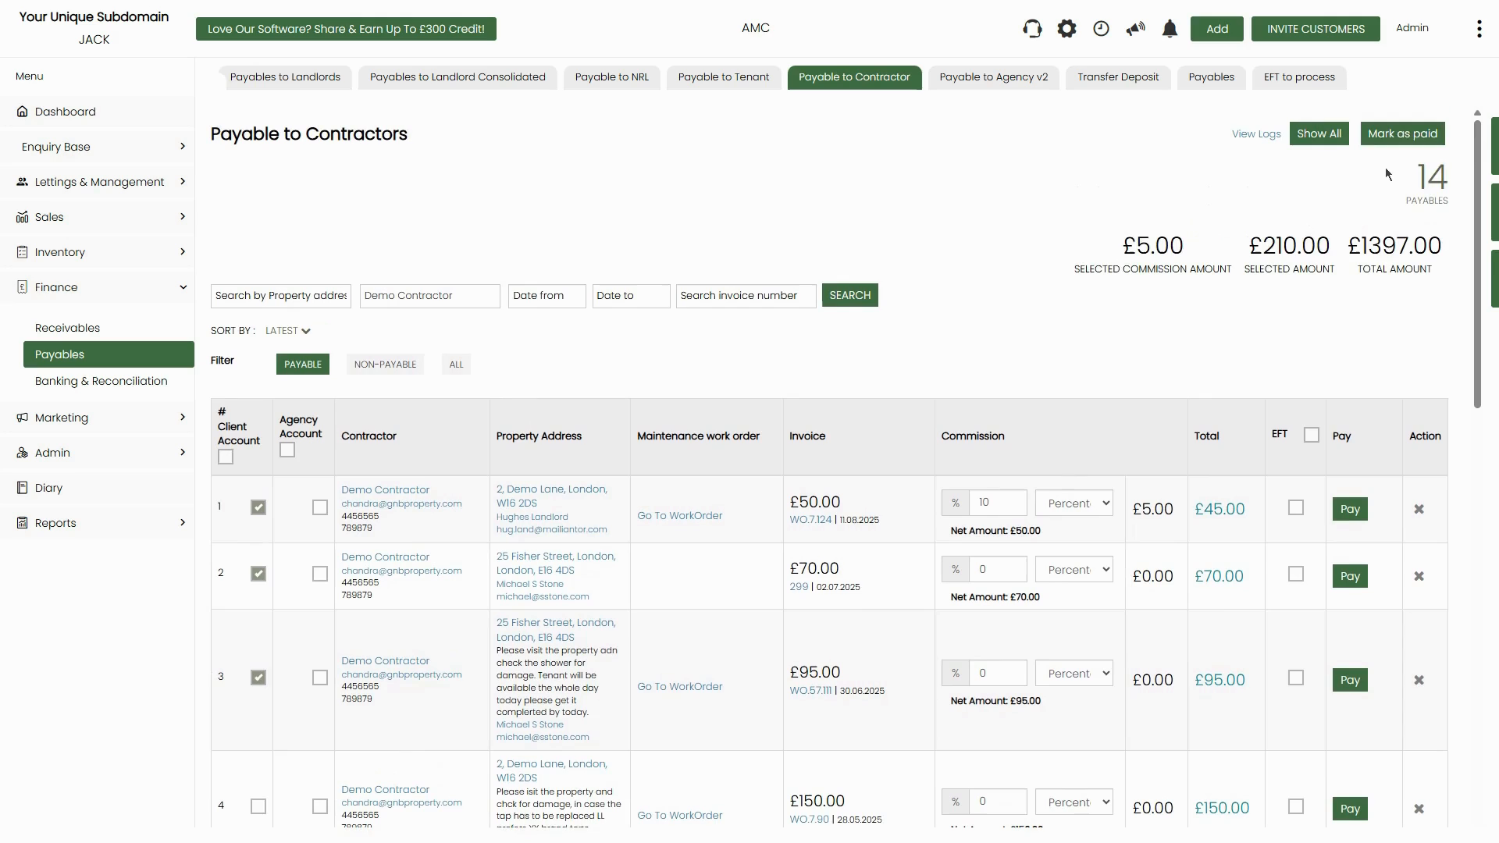

*Figure 13: Three rows selected — Selected Commission Amount (£5.00) and Selected Amount (£210.00) shown, and 'Mark as paid' button visible top-right*

**Step 2: Click 'Mark as Paid' and Complete the Form**

Click the Mark as paid button (top-right). A dialog will appear showing the contractor name, invoice reference, and property address for the first selected invoice, followed by the payment form. Fill in the same fields as for individual payment (Amount paid, Payment date, Payment method, Paying from, Bank reference, Statement Remark).

After completing the form, click SUBMIT. A 'Please wait while generating PDF' loading indicator will appear as the system processes all selected invoices.

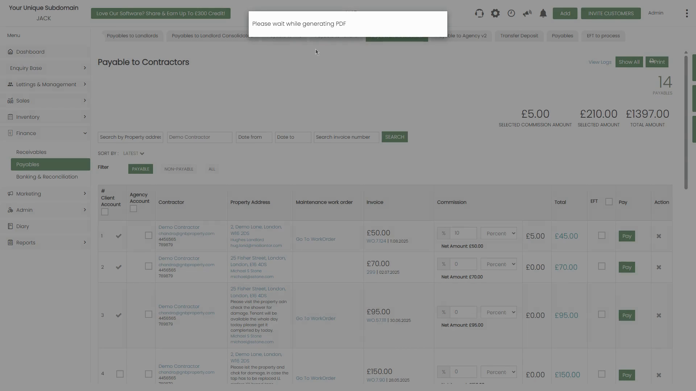

*Figure 14: 'Please wait while generating PDF' indicator — the system is processing the bulk payment and generating payment records*

**📌 Note:** After bulk processing, a PDF summary may be generated automatically. The invoices will be removed from the PAYABLE list and marked as paid in the contractor's payment history.

# **Checking and Updating Contractor Bank Details**

For EFT/BACs payments to work, the contractor must have their bank details set up on their record. If bank details are missing, the EFT payment cannot be processed. To check or update a contractor's bank details:

* Open the contractor's profile from the CRM (search in Enquiry Base or click the contractor name).
* On the contractor profile, scroll down to the Bank Details section.
* Enter the Account name, Account number, Sort code, Bank name, and optionally IBAN and Swift code.
* You can also set a default Commission rate on the contractor profile — this will pre-fill the commission field on all their invoices in the payables list.

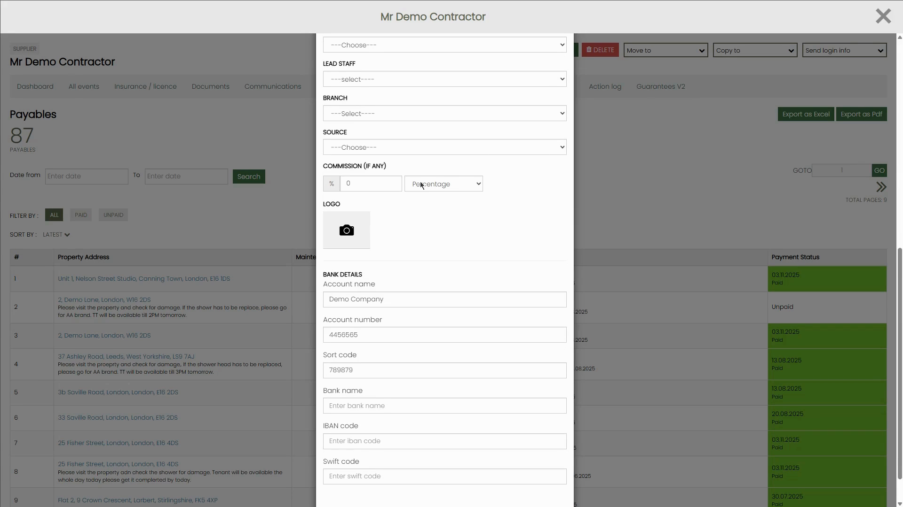

*Figure 15: Contractor profile — Bank Details section showing Account name, Account number, Sort code. Commission can also be set here as a default*

**📌 Note:** The contractor's Payables tab (on their profile page) shows all invoices for that contractor with their payment status — ALL, PAID, or UNPAID. Use this to review payment history for a specific contractor.

# **Quick Reference Summary**

| **Topic** | **Detail** |
| --- | --- |
| **Where to start** | Finance → Payables → Payable to Contractor |
| **What you see** | One row per contractor invoice — contractor name, property, maintenance work order, invoice amount, commission field, net total, EFT checkbox, Pay button |
| **Red ! icon** | Invoice not yet deducted from landlord/tenant statement — payment cannot be processed until deducted first |
| **Commission field** | Enter % or flat amount to deduct your agency fee from the contractor payment before paying |
| **Pay individually** | Click the green Pay button → Mark as paid form → fill details → SUBMIT |
| **Batch EFT/BACs** | Tick EFT checkbox → go to EFT to process tab → Make payments and Generate BACs → SUBMIT |
| **Bulk Mark as Paid** | Tick Client Account checkboxes → Mark as paid button appears → fill form → SUBMIT |
| **Search / Filter** | Search by property address, contractor name, date range, or invoice number. Filter: PAYABLE / NON-PAYABLE / ALL |
| **Contractor bank details** | Must be set up on the contractor record before EFT/BACs payments can be processed |
| **Print/Export** | Use Print or Export as Excel buttons (top-right) to get a report of outstanding payables |